My Week 1 Engineering Onboarding Journey at FloCard: Version Control, Tools, and Processes

1. Deep Dive: Git & Version Management
To kick off the week, I brushed up on version control fundamentals and explored how decentralized code management functions in a fast-paced, collaborative team environment.

Core Git Mechanics
- Staging Area (git add): Acting as a middle ground or a "preview" environment before saving changes permanently. It allows developers to selectively group related modifications together.
- Commits (git commit -m "..."): Creating a permanent snapshot of the staged changes in the project history. Good commits act as checkpoints accompanied by descriptive messages.
- Push & Pull (git push / git pull): Push uploads local branch commits to the remote repository (GitHub), while pull fetches and integrates changes from the remote repository into the local working directory to keep things synced.
- Merge (git merge): Combining histories from different branches (e.g., merging a feature branch back into the development branch).

Branching Strategy
We look at an industry-standard, clean branching strategy to prevent code conflicts:
- main: The highly protected, production-ready branch. Code here is live and stable.
- dev: The integration branch for features. This is where active development pieces converge and get tested.
- feature/*: Short-lived, isolated branches created by individual developers to work on specific tasks or user stories (e.g., feature/login-validation). Once done, these open a Pull Request (PR) to merge into dev.

What Git Solves in Teams
Without Git, collaborative development is chaotic. Git resolves critical engineering pain points by:
- Eliminating overwritten code when two developers modify the same file simultaneously.
- Providing a perfect historical audit trail to track who introduced what change, and why.
- Allowing easy rollbacks to stable versions if a catastrophic bug breaks production.

2. Hands-on Project: My First Repository
To practice these concepts, I set up a dedicated repository to store my onboarding progress and learning notes.
- Repository Name: warmup-first-repo
- Visibility: Public/Private (As per team alignment)
- Live Action: I successfully initialized the repository, created a comprehensive README.md summarizing my initial takeaways, and practiced the commit cycle by making 1-2 structured commits to master terminal commands.
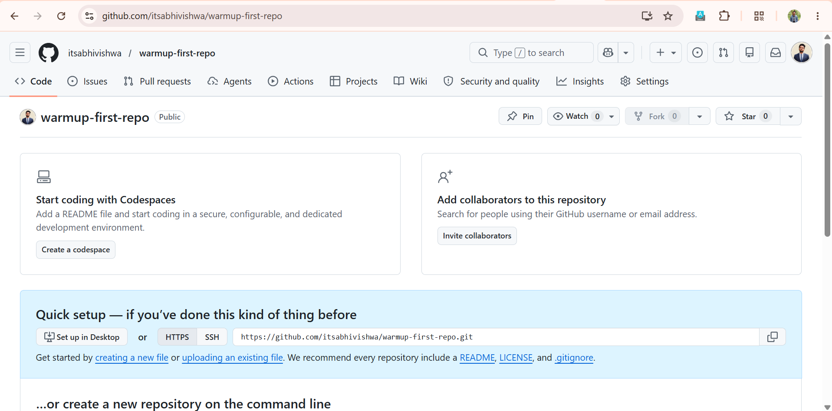

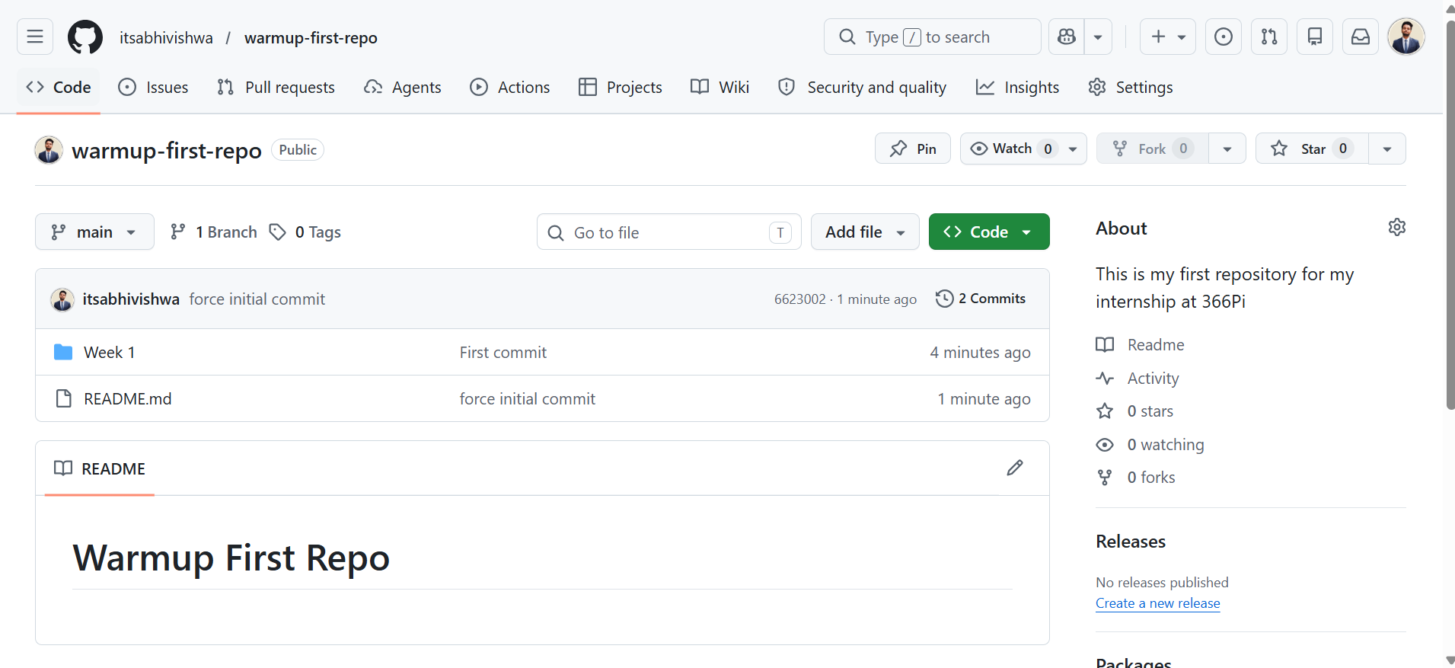

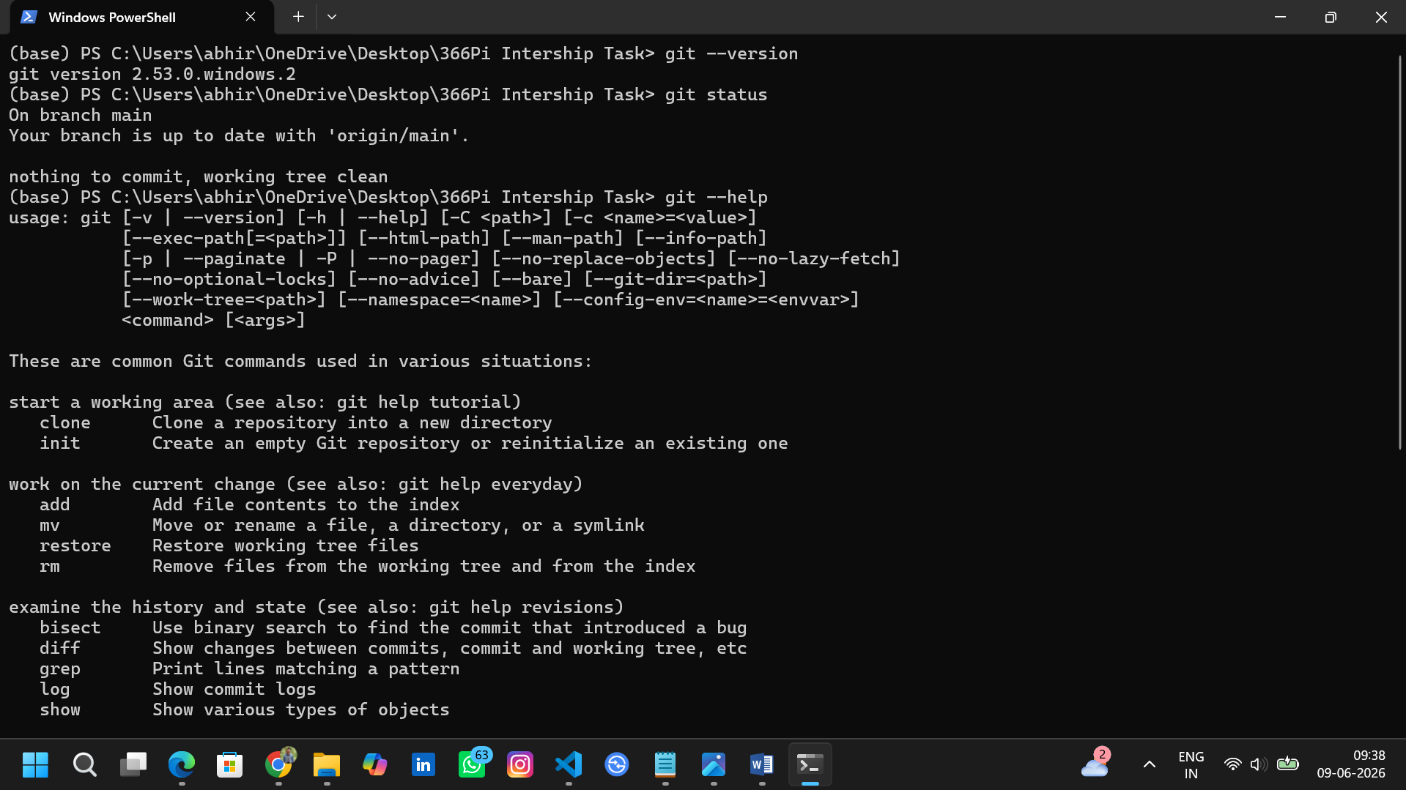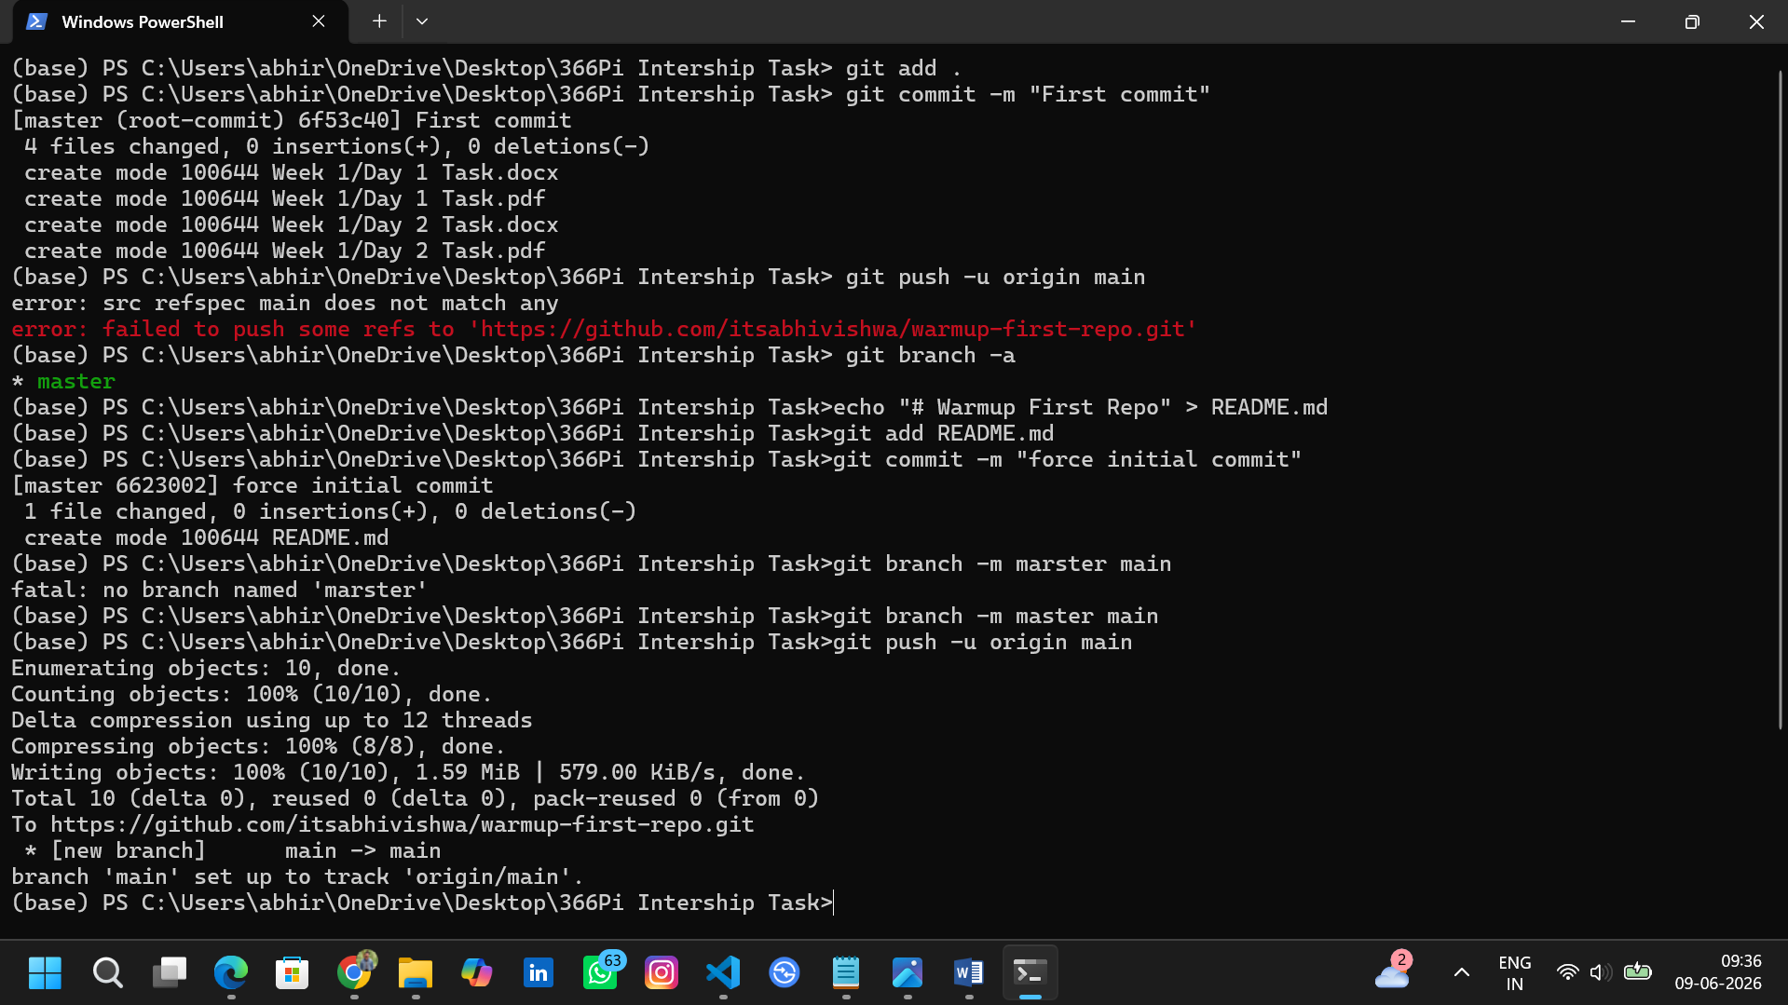

3. Demystifying the Release Management Process
Understanding code is only half the battle; knowing how that code safely reaches production is what ensures product stability.

What a "Release" Means at FloCard
At FloCard, a release isn't just about pushing code live. It represents a strictly validated bundle of tested features, enhancements, and bug fixes packaged together to deliver reliable business value to our users.

The Workflow: QA, Testing, FOU, and Deployment
Based on internal guidelines, a release moves through strict quality checkpoints:
- Clear Scope & Tracking: Every task or bug must be clearly categorized, given explicit effort estimations, and mapped perfectly to an Epic in Jira.
- Strict Time Boxing: Sprints run on fixed cycles. To ensure smooth coordination, all updates, blockers, and progress details must be noted in daily updates, ensuring team-wide dependency mapping happens seamlessly.
- The Quality Gate (QA & FOU): Code goes through rigid testing protocols and detailed code reviews. Before anything hits production, the testing team prepares and submits a Fitness of Use (FOU) Certification. Confirming that this FOU is signed off ensures that the product is completely stable and functions exactly as expected for the end customer.
- DevOps Logging: Every test case scenario and execution metric is diligently logged in DevOps to preserve accountability and traceability before final deployment.

3.1 Release Process at 366Pi

Step 1: ClearScope – Scope Definition
The goal of this phase is to establish a detailed, well-defined scope for every release by identifying all features, enhancements, and bug fixes.
- Core Components:
  - Feature Identification: Listing out all new features and planned enhancements.
  - Bug Fixes: Documenting every known issue that needs a resolution.
  - Dependencies: Pre-identifying potential conflicts or cross-team blockers.
- Action Plan:
  - Issue Definition and Categorization: Classifying tasks properly (Epic, story, issue, bug) and linking them to a master Epic for full traceability.
  - Detailed Descriptions and Outcomes: Providing clear objectives and defining measurable, expected outcomes for each issue.
  - Timeline and Effort Estimation: Setting clean start/end dates and mapping realistic estimated hours to streamline workload management.

Step 2: ReleaseTimeline – Schedule Planning
This phase focuses on developing a comprehensive release schedule that outlines core milestones, deadlines, and responsibilities so the team can plan accordingly.
- Core Components:
  - Milestone Mapping: Outlining key milestones and establishing firm deadlines.
  - People Allocation: Assigning tasks and defining ownership across resources.
  - Risk Management: Spotting potential delivery risks early and creating mitigation paths.
- Action Plan:
  - Sprint Planning and Item Categorization: Mapping items correctly into a standard 15-day sprint cycle and clearly separating staging releases from production releases.
  - Documentation and Quality Check: Confirming that production items are fully documented and setting up regular intermediate check-ins.
  - Timeline and Communication: Reviewing release health at the end of the first Friday. All final release activities must be wrapped up without fail by 3:00 PM IST on Friday.

Step 3: QualityGate – Quality Assurance
The final phase enforces strict quality control standards to validate that the code is stable, functional, and ready for deployment.
- Core Components:
  - Testing Protocols: Establishing robust and comprehensive testing frameworks.
  - Code Review: Executing deep code reviews to maintain architecture standards.
  - Validation: Performing final system checks to confirm everything runs as intended.
- Action Plan:
  - Fitness of Use (FOU) Certification: The testing team must prepare and submit an FOU certificate for every release, confirming that the end customer has received and approved it.
  - Comprehensive Testing and Documentation: Ensuring that test coverage spans all real-world scenarios and that every test log is officially recorded in DevOps.
  - Performance and Promptness: Tracking testing efficiency to ensure no deadlines are missed, and dynamically increasing testing urgency for critical production environments when needed.

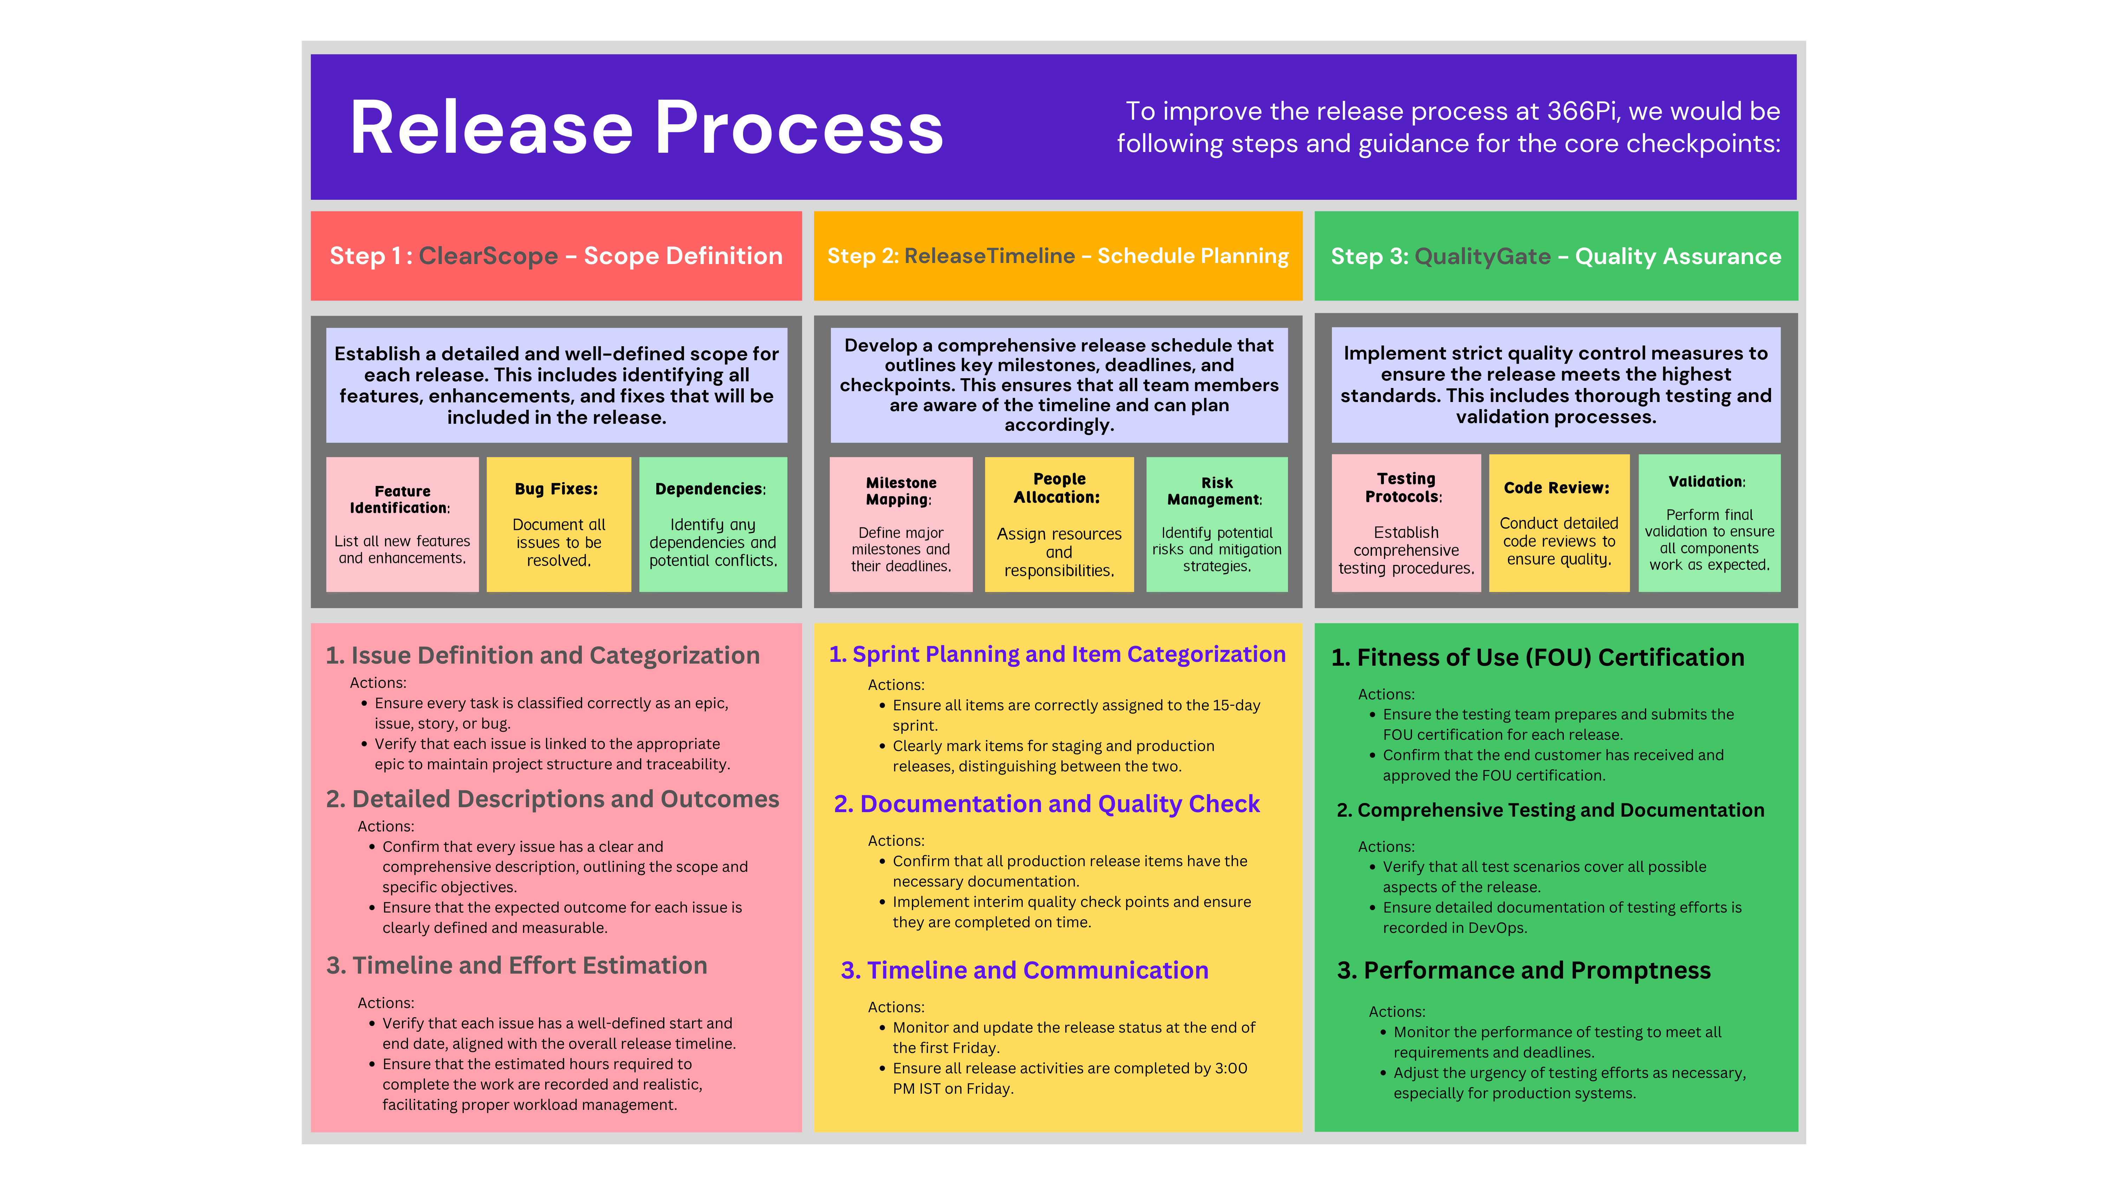

4. Local Development Environment Setup
I successfully installed, configured, and verified the primary toolstack required to build, test, and containerize applications at FloCard.
Here is the list of tools along with their terminal validation checks:
Tool | Purpose | Verification Command | Output / Status
Git CLI | Distributed version control tracking via terminal | git --version | Verified & Operational
VS Code | Primary Lightweight IDE for script editing & development | code --version | Extension packs installed
Postman | API testing client for hitting endpoints and inspecting payloads | Desktop App | Confirmed working locally
Node.js | JavaScript runtime environment for backend services | node -v | Installed (LTS version)
NPM | Package manager to manage project dependencies | npm -v | Operational
Docker Desktop | Containerization tool to spin up local staging/database microservices | docker --version | Basic engine configured & active

Attached images at the end.

5. Summary of Week 1 Deliverables
As I conclude my first week, I am happy to report that all core milestones have been hit:
- warmup-first-repo: Live on GitHub containing my written documentation and onboarding notes.
- FloCard Workspace Connection: Successfully onboarded to Slack, Jira, and Microsoft Teams channels, aligning perfectly with regular daily checkpoint communication protocols.
- One-Pager Product Write-Up: Completed a conceptual architecture document mapping our product flows, primary user personas, and target use cases.
- Verified Workspace: All critical software, database runtimes, and local testing clients are verified via CLI and ready for code execution in Week 2.


